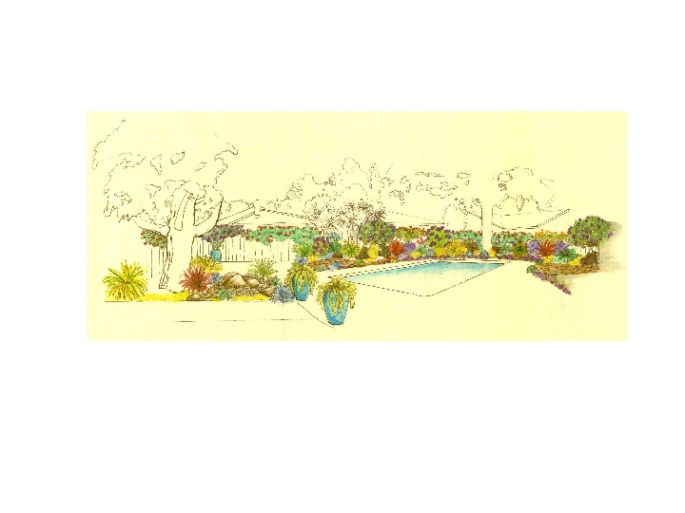
Stonehedge Swim Club

PARTY AND EVENT 2017
A non-profit corporation owned by eligible residents of the Stonehedge Development community
RULES AND REGULATIONS
Of the Stonehedge Swim Club, Inc.
(A California Non-Profit Corporation)
Membership in the Stonehedge Swim Club requires adherence to these Rules and Regulations. All household members, including children and guests, must be cognizant and respectful of these Rules. The Stonehedge Swim Club Rules and Regulations apply at all times without exception.
Rules and Procedures for Hosting a Party or Event
- The pool is available to Members as a venue for hosting parties, on a first come/first served basis. All SSC Rules and Regulations must be followed by guests at all times. Member Hosts are responsible for their guests and their guest’s conduct while on the Stonehedge Swim Club grounds. A Member must be in attendance for the duration of the party.
- Party reservations can be no more than ten (10) days in advance.
Members must post a notice on the Pool Gate with all of the following information:
a) Name of Member hosting event;
b) Date and time of event;
c) Member contact phone number and/or email.
- A group of six (6) or more guests is considered a party. The maximum number of guests allowed is 20.
- Members are asked to limit parties to two (2) per household, per season.
- Parties may occur between the hours of 10:00 AM and 8:00 PM, and may last up to two (2) hours maximum of swim time, plus an additional 30 minutes before the party for prep and an additional 30 minutes after the party for clean-up. Please do not have guests and party detritus linger after the 2 hours has expired.
- Parties with children under the age of 18 require designated and dedicated adult supervision at all times, with a Child/Adult ratio of 4/1. Please arrange who will be on “life-guard” duty prior to event.
- Parties of 12 or more minor children require hiring a certified lifeguard, at the expense of the Member. There are NO exceptions to this rule.
- Only one party can be hosted at a time, and we encourage no more than one party on any given day.
- Member hosts are required to clean up all debris from party, including hosing down concrete, hauling trash from event, and leaving pool grounds in pre-party condition.
- No loud music, screaming, or intrusive games are allowed at the party. Remind guests there is NO diving or climbing onto shoulders allowed.
- No rafts or inner tubes may be used during a party. Floatation swim aids are allowed for children under 10.
- ALL Members are allowed to use the Stonehedge Swim Club grounds and pool during a party. Reserving a party day and time does NOT give a Member exclusive use of the pool or pool grounds, it is simply a courtesy to make other members aware that a party is being hosted. Members are still welcome to use the pool.
- Violations of these Rules and Procedures may compromise Membership eligibility.

